**Finding the words and their frequencies in given data using HADOOP MAPREDUCE**

1. **Starting all Hadoop daemons**

* cd hadoop-3.2.1/
* cd sbin
* ./start-all.sh
* Jps

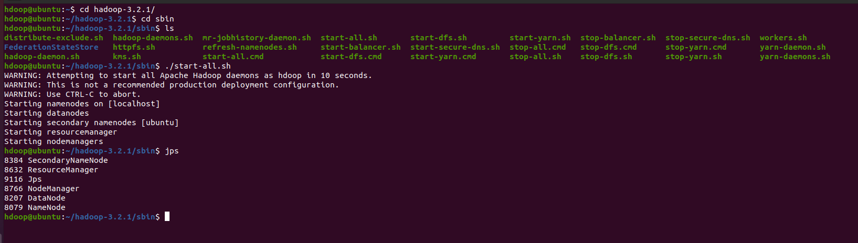

1. **Verifying the namenode’s status and application status**

* Go to browser and type <http://localhost:8088/> and <http://localhost:9870/> and check for active status.

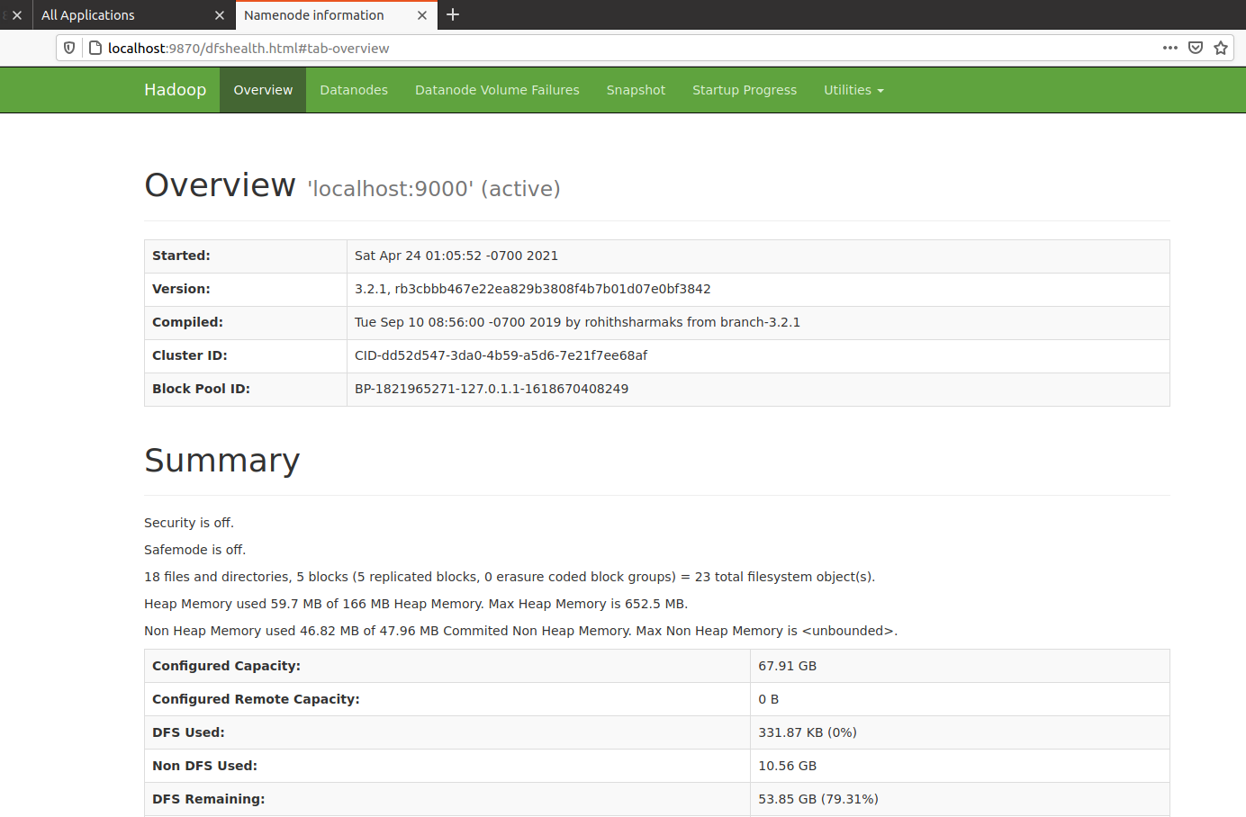

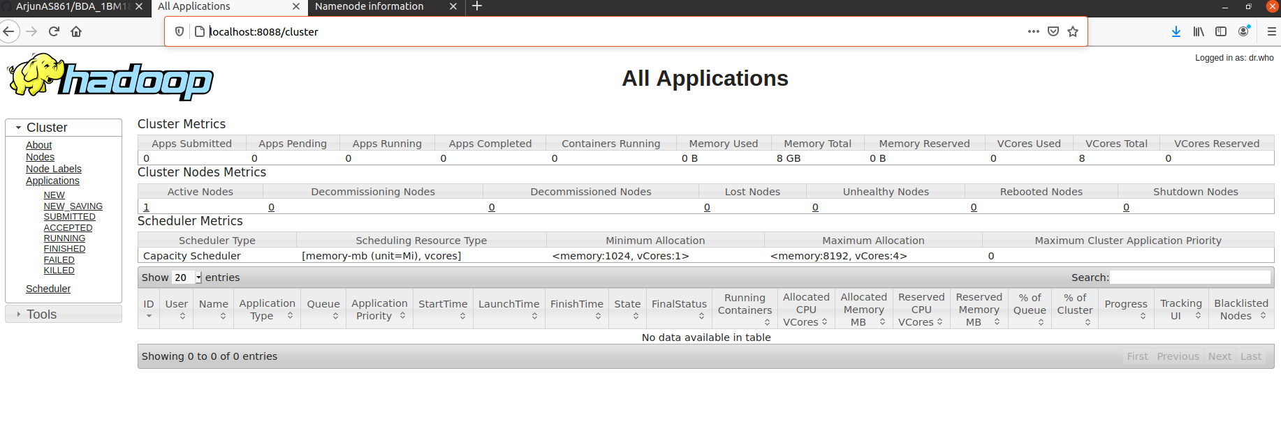

1. **Creating a sample file for input in local system and moving it to dfs**

* Create a file in local system
* cd Downloads
* nano word_sample.txt
* cat word_sample.txt
* Go to Hadoop-3.2.1 directory and execute following commands
  + Hdfs dfs -ls /
* Create a folder in Hadoop for placing input files.
  + hdfs dfs -mkdir /input
  + hdfs dfs -copyFromLocal ~/Downloads/word_sample.txt /input
  + hdfs dfs -ls /input
  + hdfs dfs -cat /input/word_sample.txt

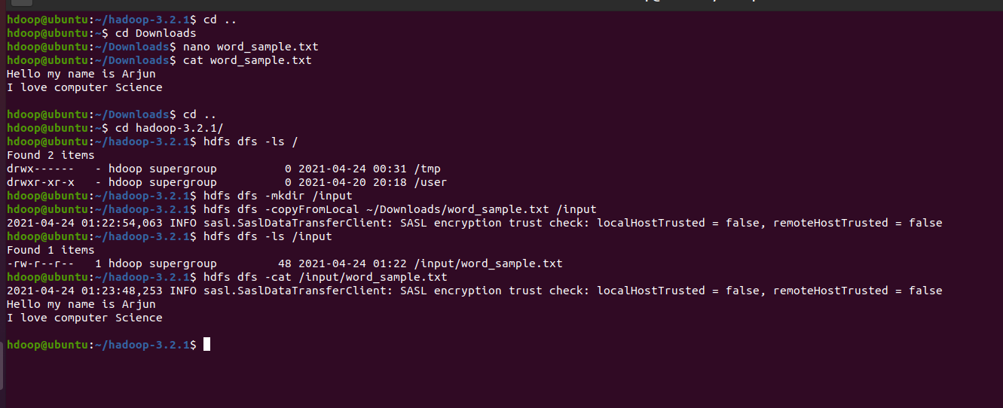

1. **Using MapreduceClient.jar file to calculate wordcount**

* The java code to calculate word count is in wordcount.jar and also use MapReduceClient.jar

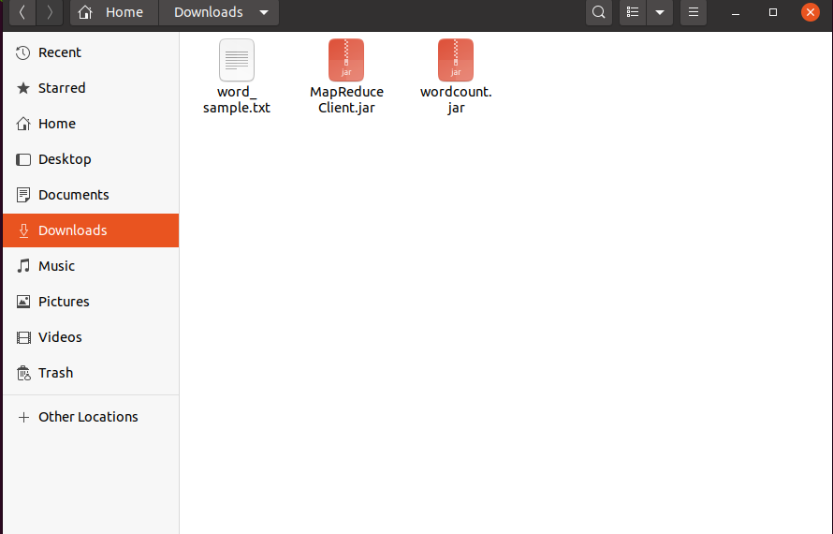

* Execute hadoop jar /home/hdoop/Downloads/MapReduceClient.jar wordcount /input /output

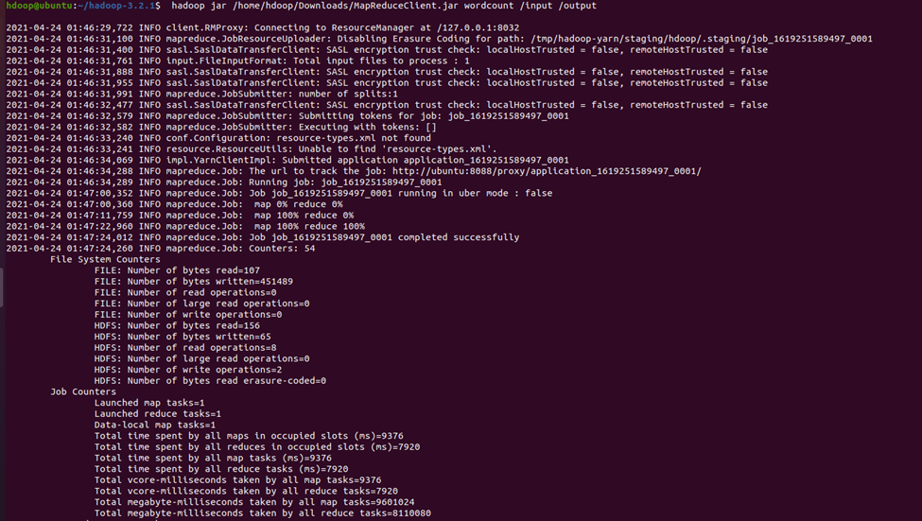

* A new application will be running with final status as undefined and after completion of the task finalStatus is set to Succeded in http://localhost:8088/

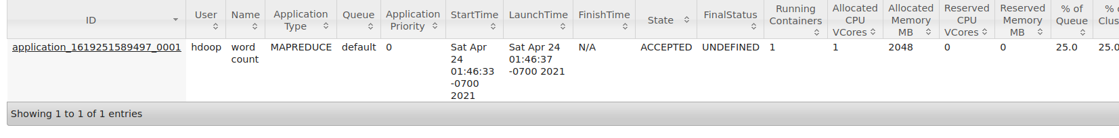

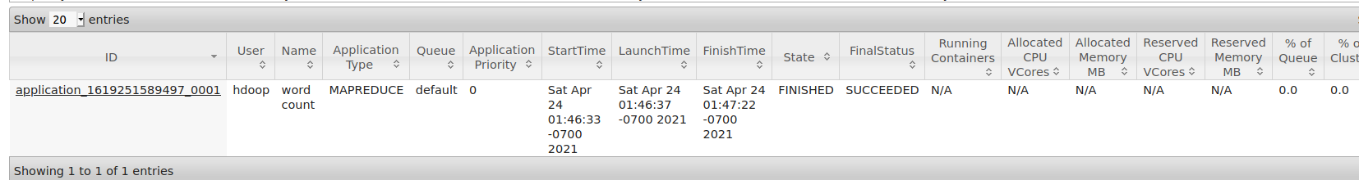

1. **Viewing the output**

* hdfs dfs -cat /output/*

